

Functional Document – AXA Document Management

Date: 19/10/2021

Author: Saurabh Sah

© 2021 Project Objects Ltd

**Table** **of Contents**

1. Introduction 3

* 1. 1.1. Company Settings 3

1.1.1. When Disable 3

1.1.2. When Enable 3

* 1. 1.2. Standard Codes Master Pages 3

1.2.1. Project Size 3

1.2.2. Document Type 4

1.2.3. Document Management 4

1.2.4. Creation of Document Management 5

* 1. 1.3. Project Form 6
  2. 1.4. Document Form 6

1.4.1. Document Management Control 6

1.4.2. Mandatory Control 7

* 1. 1.5. Threshold Setting 7
  2. 1.6. Reporting Key Library 8
  3. 1.7. Dashboard Reporting 8

# Introduction

This document is targeted to propose the solution for Document Management requirement for AXA.

## Company Settings

There will be an option available at company setting page to enable/disable the document management functionality. Based on this setting, the master pages, health key and threshold setting related to document management in standard codes will be visible.

### When Disable

By default, the checkbox will appear unchecked, which means, the document management is disabled currently.



### When Enable

When user enables it, there will be a dropdown appear which contains all the document form names created in the system. The document will be created on the selection of project size on the selected form in the document process dropdown.

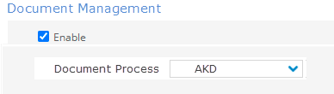

## Standard Codes Master Pages

We will require 3 master pages to be added in the **standard codes > project managment**.

* Project Size
* Document Type
* Document Management

### Project Size

Here, user can define the project size. Which will be later populated in the Document Management master table. Once the project size value is used in Document Management table, it cannot be deleted at master table. Only renaming is possible.

Once user renames the **project size** label, it will reflect on Document Management master table and existing projects as well.

### Document Type

In this page, user will have the possibility to add the document type. Once used in project, the document type cannot be deleted. User will have the possibility to rename it and the label will reflect in existing project as well.

### Document Management

There will be a **Document Management** tab under **Standard Codes > Project Management**. This tab will show the data created for document management.

1. **Project Size** – It will be mandatory dropdown and value will come from **Project Size** master table
2. **Document Type** – It will be mandatory dropdown and value will come from **Document Type** master table.
3. **Weight** – It will be mandatory and numeric field.
4. **Mandatory** – It will be mandatory dropdown field with values Yes and No.
5. **DFS** – It will load DFS structure if created. It will be optional to select.
6. **Add Default** – This will have a checkbox to enable or disable.

#### **Special Conditions**

* **Project Size** and **Document Type** will be a unique document for this page. Meaning, 1 document type cannot be added multiple time in a single project size.
* Any creation/deletion of document made at the standard codes doesn’t affect the already created project.
* If user changes the **weight** value at Standard codes, it will update all the corresponding documents of that particular **Document Type**.

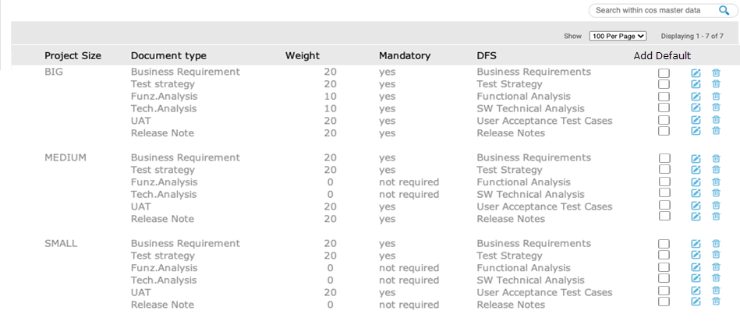

### Creation of Document Management

If user click on create button, an inline create option will appear. Here, user can define the values accordingly.

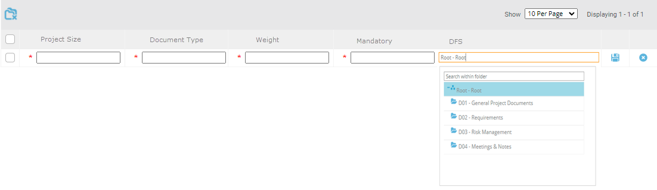

#### Special Behaviour

* **Project Size** – description can be edited anytime. The change will reflect in existing projects as well.
* **Document Type** – New document type can be added any time. **But it will not affect the already created projects.** When new project will be created, then only it will reflect.
* **Weight** – can be modified anytime. It will also affect the KPI’s calculation for existing projects as well.
* **Mandatory** – This field can be edited anytime in the Standard Codes, but it will not affect the already created documents.
* **DFS** – This field can be edited anytime in the Standard Codes, but it will not affect the already created documents.
* **AKD Number** – It will follow the current object numbering feature of the application.

## Project Form

We need to build a user control named as **Project Size**. It will be available only for project type forms. It will be a dropdown field which gets the data of the project size from the **Standard codes > Project Management > Project Size.**

When user selects the project size for the first time and click on apply, there will be a informative message appear that ***“Project Size selection will create the documents defined in the document management”***. Once user confirm, the document defined of that project size will be created where **Add Default** is checked.

If user changes the existing selection and select any other value, a warning appear that ***“*You have changed project size. Once you apply the changes, any standard documents missing, will be added*.”*** – this action will only create those documents of the new selected project size, whose Document Type is not already created and **Add Default** is checked.

If user changes the description of the current project size, or creates a new one, the project size dropdown will show the latest values.

This field project size will be always editable (if allowed from form section permission). User can change the value at any time if he has access to this control. Once the project size is changed, the list of documents will be created and will start appearing in the workspace widget and teamspace register for that particular document form.

## Document Form

New documents will be created against each project on the selection of Project Size based on the configuration at Standard Codes. User will also have the possibility to create the document from teamspace form as well.

We also need to build 2 user control (only be available for document forms) which will show below field:

### Document Management Control

* **Document Type** – dropdown – for automatically created document, it will show the value of Document Type as per the configuration at Standard Codes and will appear read only.

If user creates the document from team-space form, in this case, the Document Type will appear editable, and after the save, it will turn in RO.

It will not allowed to create duplicate document for each project where combination of **Project Size** and **Document Type** is already created.

* **Weight** – it will be a read only field which will get data from Standard codes configuration. For manual, it will be always editable.
* **Status** – It will be an editable dropdown. Value of this fields will be-
  + Not Delevered Not started (value = 0)
  + Delevered In progress (value = 0)
  + Approved (value = 1)

**Value will be used to calculate KPI.**

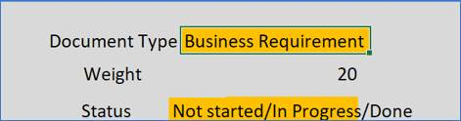

### Mandatory Control

**Mandatory** – it will be a read only field which will get data from Standard codes configuration. For manually created documents, it will be always editable.



#### **Special Conditions**

* Document will always create in same order of Document Type
* If Project Size is changed at project level and there are aleady created document, in this case only those documents will be created whose document types are not already exist for that project.

In this case, for existing documents types, the value of **mandatory** and **weight** will be updated.

* During project size save at project level, make sure the documents gets created at the backend. It should not affect user operations, to improve the project performance.
* Version history will also be created for the changes done automatically (like change in **weight** and **mandatory** field).
* Mandatory control will also be available to be added in **Register Fields** (teamspace and workspace) and **Workflow Attributes** so that it can be used in the conditional workflow as well.

## Threshold Setting

In company settings page, a new settings will be added for threshold setting for document status. It will be used to calculate the KPIs for document management.

This setting will be only visible when document management is enabled from company settings page.

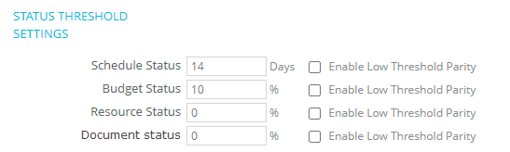

## Reporting Key Library

There will be a new key **“Document Compliance Index”** will be added in **Standard Codes > Project Management > Reporting Key Library,** that will be calculated based on the formula provided.

It will only visible when Document Management is enabled from company settings page.

This key will appear in multiple places in the application i.e. Portfolio module, status report, workspace, etc.

**Weight** and the **Status** field will be used to calculate the KPI color based on the formula provided in below table.

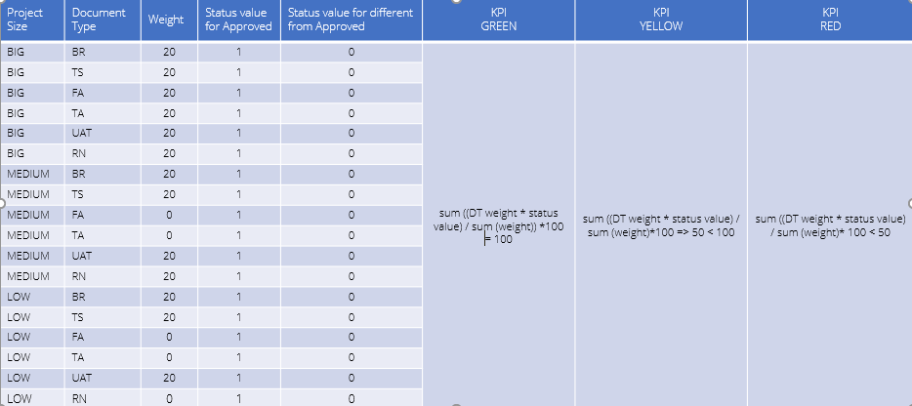

## Dashboard Reporting

The development for dashboard is out of scope for now. We will use the current API’s for now and will consider this next year.